
Appendix E2


PUSAT SEBARAN MAKLUMAT NASIONAL

NADI
CORRECTIVE MAINTENANCE FORM
SITE DETAILS

SITE NAME : NADI KG SG JUDAH
PHASE : TELEPHONY
DOCKET NO/REFERENCE : PIK_0564-0041
DOCKET DATE/TIME : 01 APRIL 2026
FAULT CATEGORY : OTHERS
FAULT DESCRIPTION : 1 UNIT LAMINATING MACHINE FAULTY

CATEGORY DAMAGE COMPLAINT:
:

COMPLAINT IN ACTION - A
COMPLAINT DONE - B
Note :
VENDOR ACTION
ACTION DATE/TIME : 08 APRIL 2026
:
:
:
:
:

:
:
:
:
ACTUAL FAULT : 1 UNIT LAMINATING MACHINE FAULTY
RESTORATION ACTION : CHANGE 1 UNIT NEW LAMINATING MACHINE
RESTORATION STATUS :
IN ACTION
PENDING
COMPLETE

NEW ACTION TAKEN : CHANGE 1 UNIT NEW LAMINATING MACHINE
COMMENT/CONCLUSION :
RECOMMENDATION :
NAME : NABILAH NAJAA BINTI DURIHAM
DESIGNATION : MANAGER NADI KG SG JUDAH
CONTACT NO : 013-6445509
DATE : 08 APRIL 2026
SIGN &STAMP :

NAME : MUHAMMAD FIRDAUS BIN MARZUKI
COMPANY : INTELLIGENCE NETCARE SDN BHD
CONTACT NO : 017-7001363
DATE : 08 APRIL 2026
SIGN &STAMP :


VENDOR VERIFICATION
NADI VERIFICATION

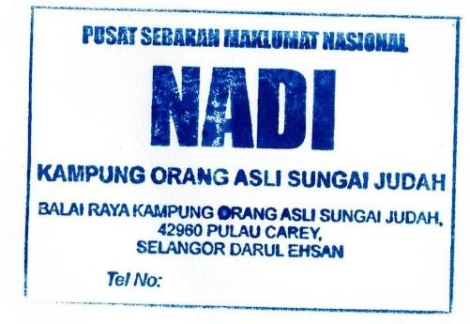

APPENDIX 1: ATTACHMENT PHOTO OF DOCKET
FAULT DESCRIPTION: 1 UNIT LAMINATING MACHINE FAULTY
RESTORATION ACTION: CHANGE 1 UNIT NEW LAMINATING MACHINE

BEFORE
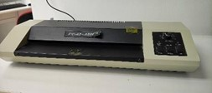
DURING
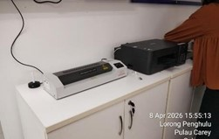
AFTER


